**Orkan Ceyhan Web Pages Documentation**

W68848

My programming project is my web pages. There are three pages. First one is main page that has informations about me. Second one is about my favorite games. Last one is about my favorite series. In this documentation, I will explain my codes meanings and why I used them.

There is main page.

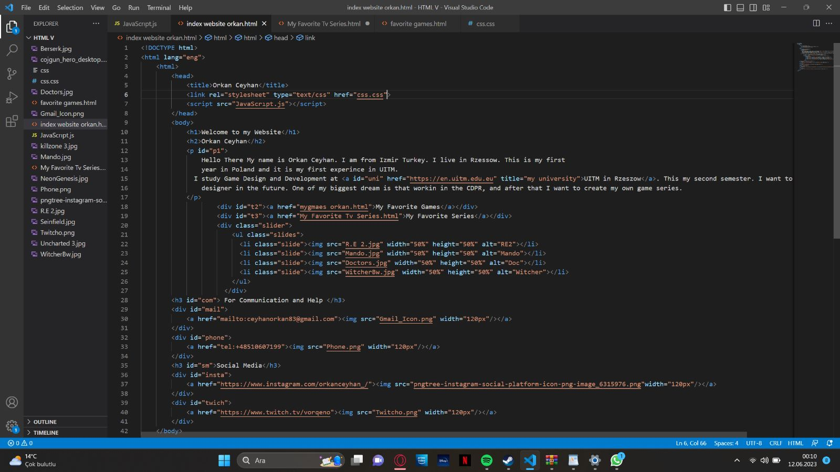

I used title tag for make my page title’s my name. After that I used h1 and h2 for headers. H1 is for the bigger header. H2 is smaller. I used “id” in most of tags. Its for identify the codes and make is easier for design in css. I used <a href> commend is for connecting with university web site and I added title for when someone click it, seens that written “my university”. Also I added some picrutes with <img src> tag. In the end I used a href tags for connecting my social media acconts, mail and my phone number.width commends are for set the size of pictures.

My favorite games page.

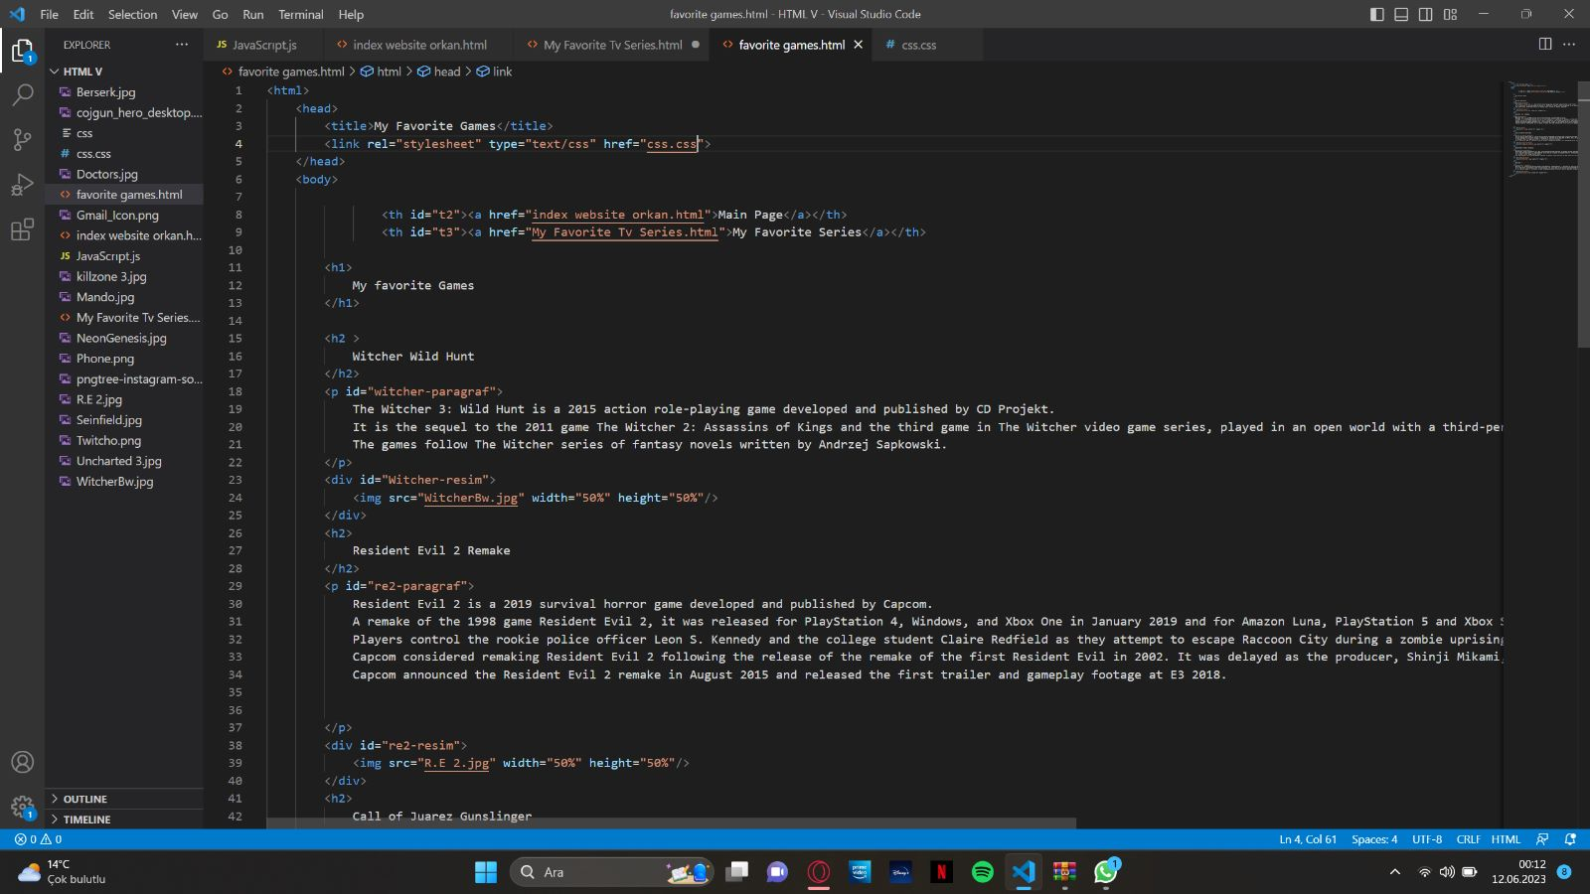

In this page, I used link tag for connecting with css codes. And a href tags for connecting with link of other pages, so its easy to open another page from diffrent page. I used long paragraphs to decribe games and for make setting position easy, I added “id” tags. So I can set positions easly in css part.

I added pictures with <img src> and set their size with <width, height>.

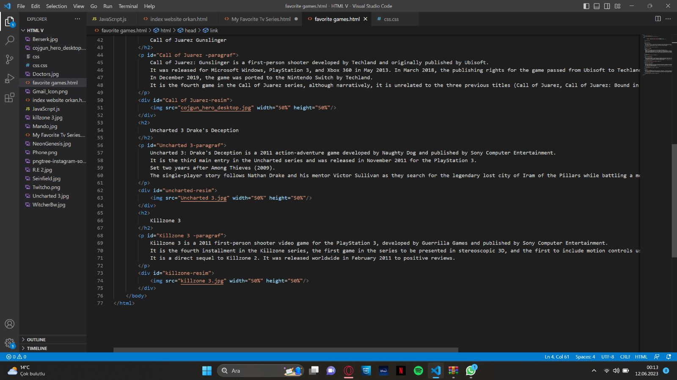

Favorite series page.

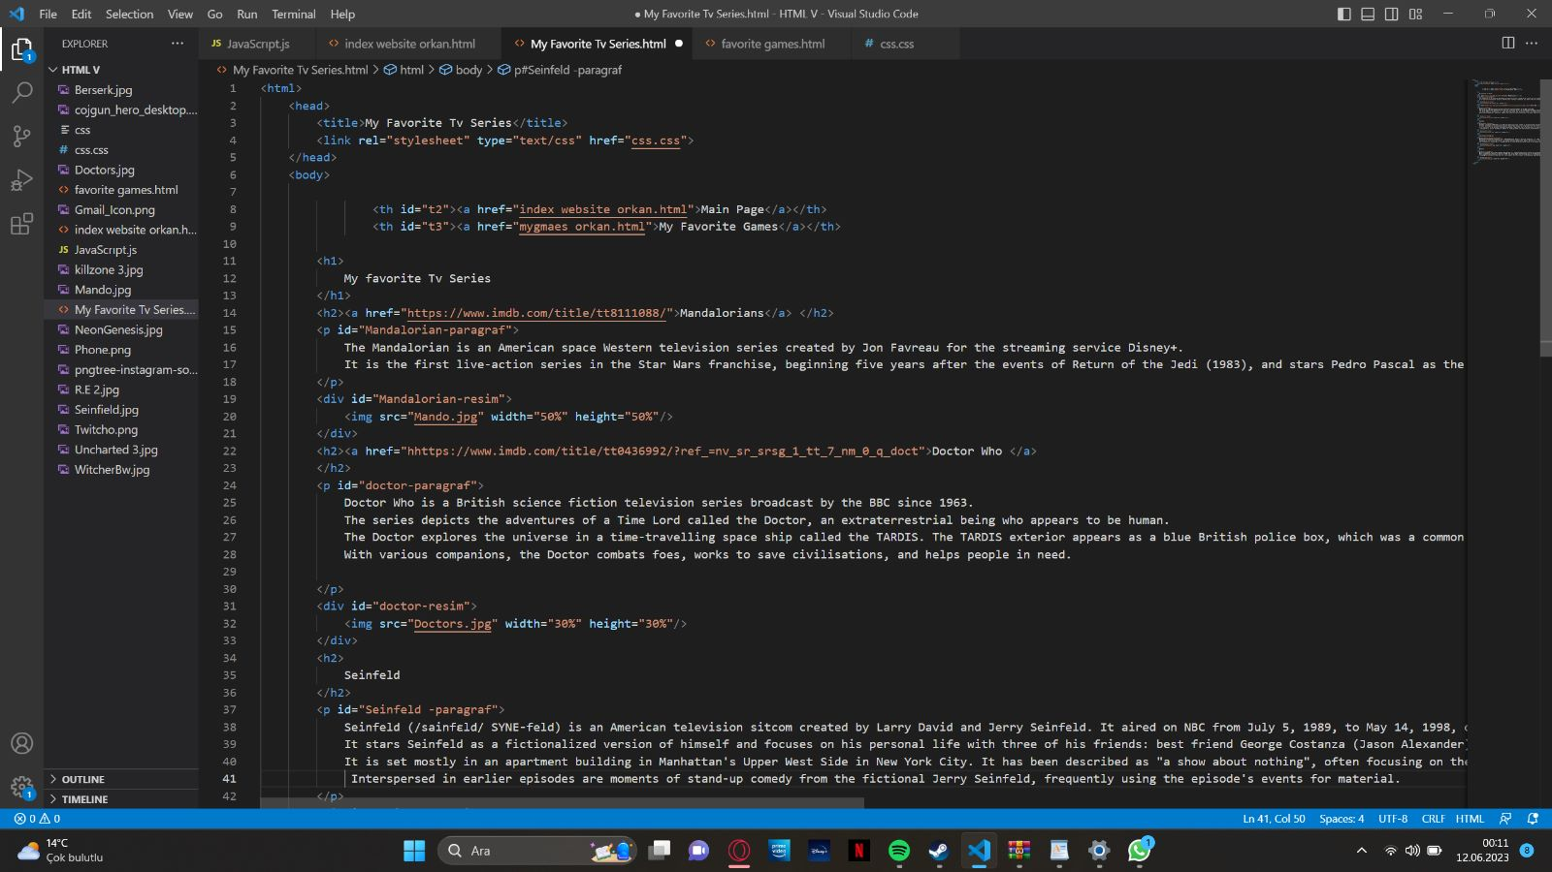

In this page, I almost used same codes as my favorite games page. But also I added links of movies with <a href>. Thus you can reach movies easly.

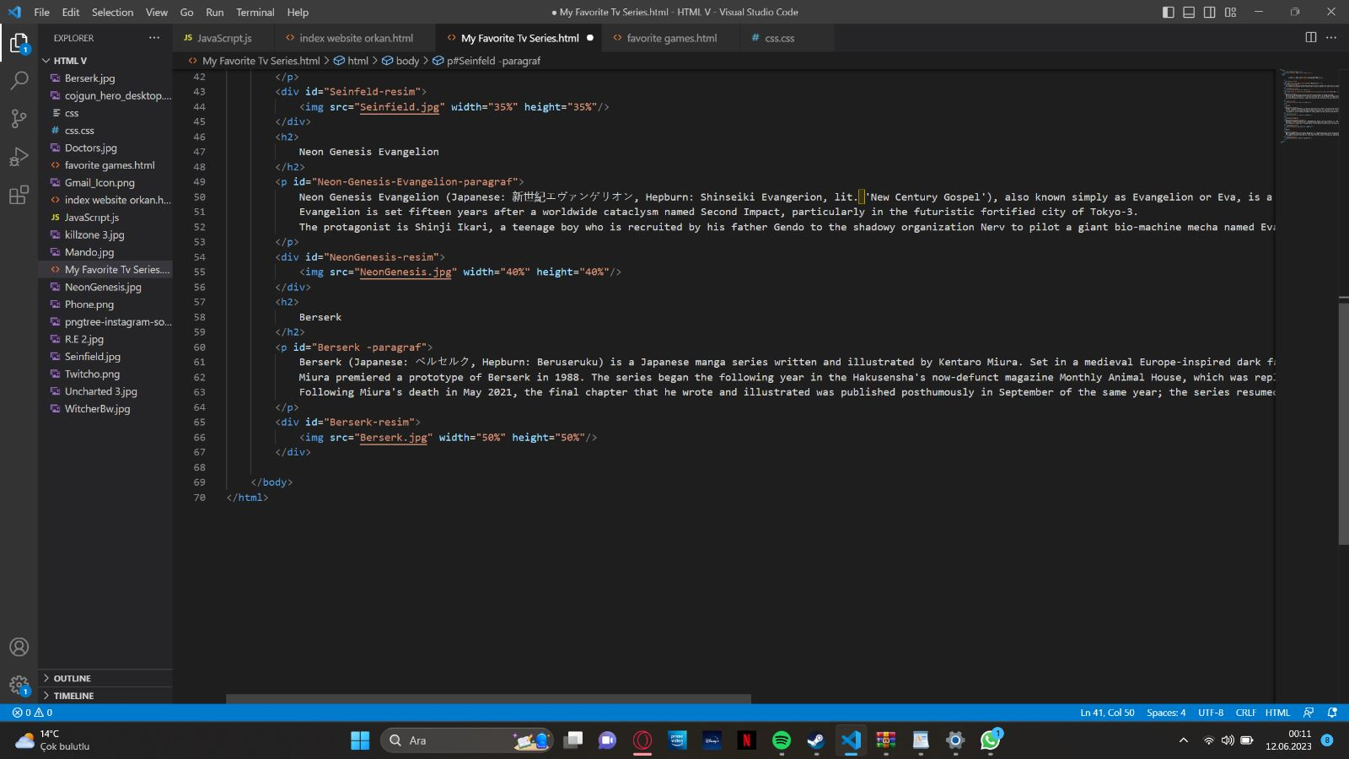

Css part:

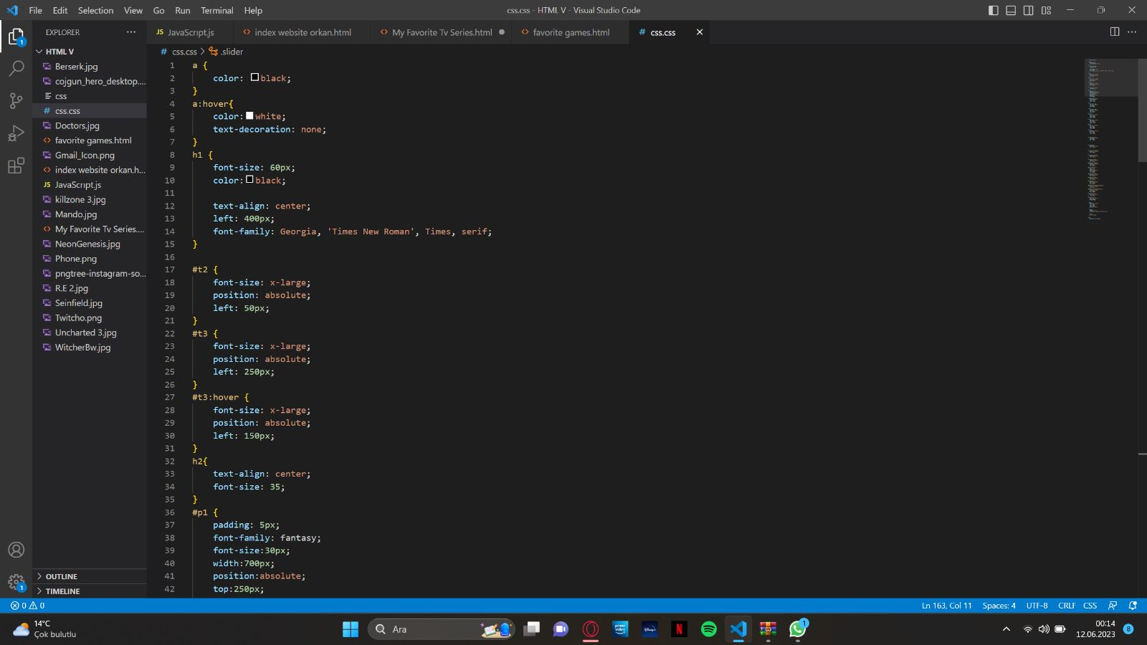

This is most excited part for me. Because I more like design. I did set colors, positions and sizes with css. For “#” this sign codes connected with “id” codes in html part. I names most codes with “id” and I call them with thir id names. I used hover because in design part I wanted to add something useful and look good. When mouse goes on code outputs, hover tag works. I used absolute position because it was easier to replace paragraphs and pictures. I used some different font-family.

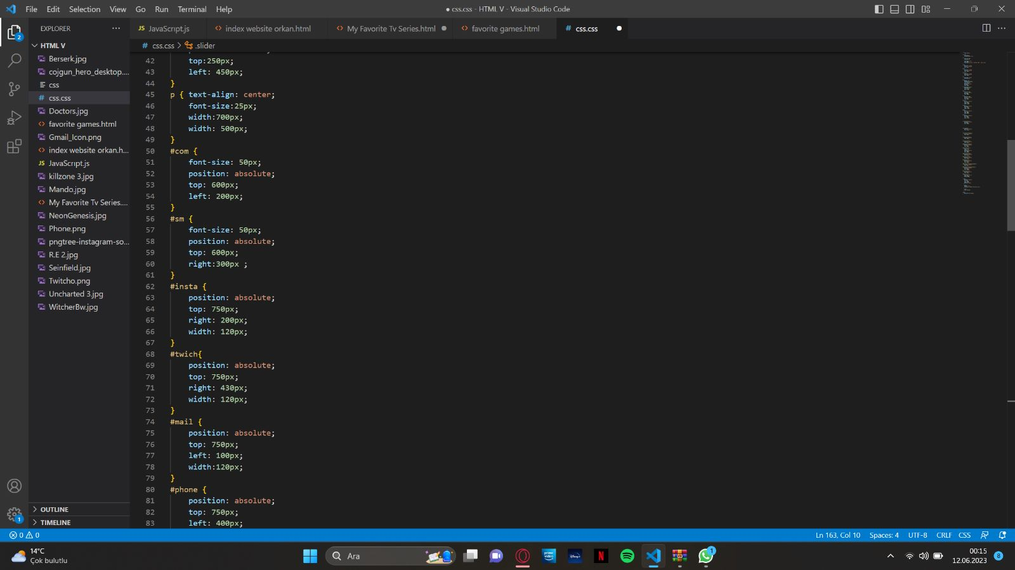

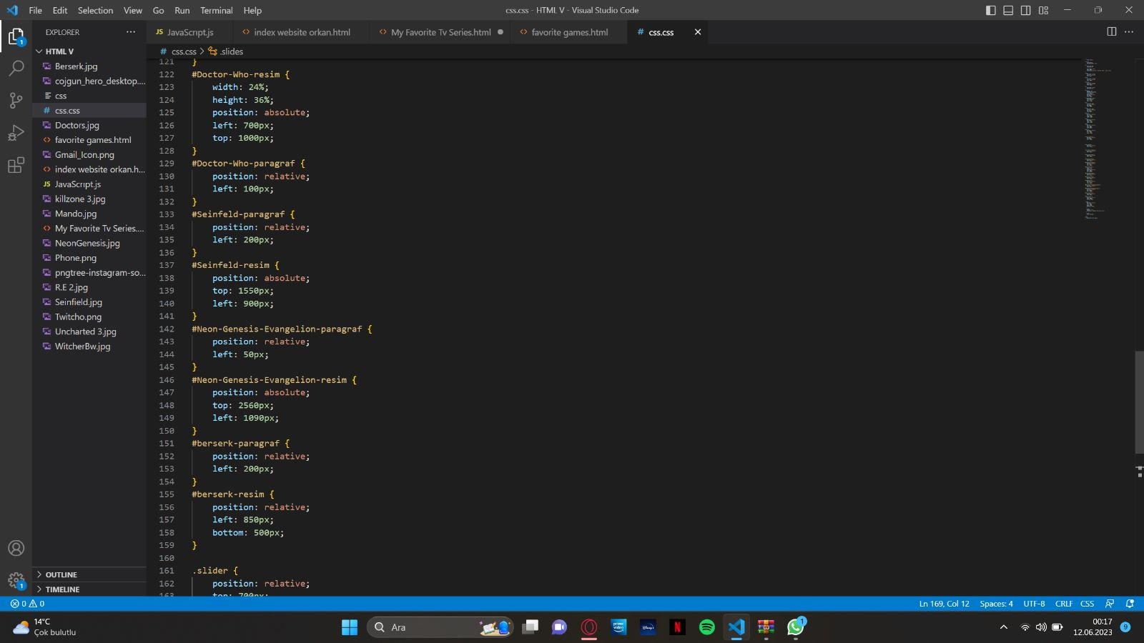

For some paragraphs I used relative position thus, all paragraphs are connect to each other and I do not need to place them single by single. These are my codes and why I used them also you can see I added my web page link so you can see my page. I hope, you like my page and design. Thank you for your interest. Best wishes.